Year 8 Math
One team member to record the results
A different team member to draw the graph and label intercepts and gradient on the whiteboard
The other team member to answer the following questions:

- Sketch a graph of the following linear relationship

y=x+1

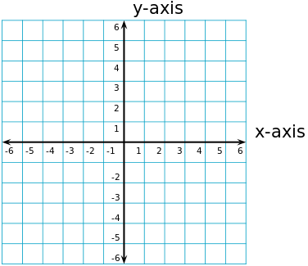

- State the x-intercept for the line

- State the coordinate of the x-intercept

- State the y-intercept for the line

- State the coordinate of the y-intercept

- State whether the gradient is positive or negative

Year 8 Math
One team member to record the results
A different team member to draw the graph and label intercepts and gradient on the whiteboard
The other team member to answer the following questions:

- Sketch a graph of the following linear relationship

y = 5x

- State the x-intercept for the line

- State the coordinate of the x-intercept

- State the y-intercept for the line

- State the coordinate of the y-intercept

- State whether the gradient is positive or negative
Year 8 Math
One team member to record the results
A different team member to draw the graph and label intercepts and gradient on the whiteboard
The other team member to answer the following questions:

- Sketch a graph of the following linear relationship

y = -3x + 6

- State the x-intercept for the line

- State the coordinate of the x-intercept

- State the y-intercept for the line

- State the coordinate of the y-intercept

- State whether the gradient is positive or negative
Year 8 Math
One team member to record the results
A different team member to draw the graph and label intercepts and gradient on the whiteboard
The other team member to answer the following questions:

- Sketch a graph of the following linear relationship

y = -x + 4

- State the x-intercept for the line

- State the coordinate of the x-intercept

- State the y-intercept for the line

- State the coordinate of the y-intercept

- State whether the gradient is positive or negative
Year 8 Math
One team member to record the results
A different team member to draw the graph and label intercepts and gradient on the whiteboard
The other team member to answer the following questions:

- Sketch a graph of the following linear relationship

y = -2

- State the x-intercept for the line

- State the coordinate of the x-intercept

- State the y-intercept for the line

- State the coordinate of the y-intercept

- State whether the gradient is positive or negative
Answers:
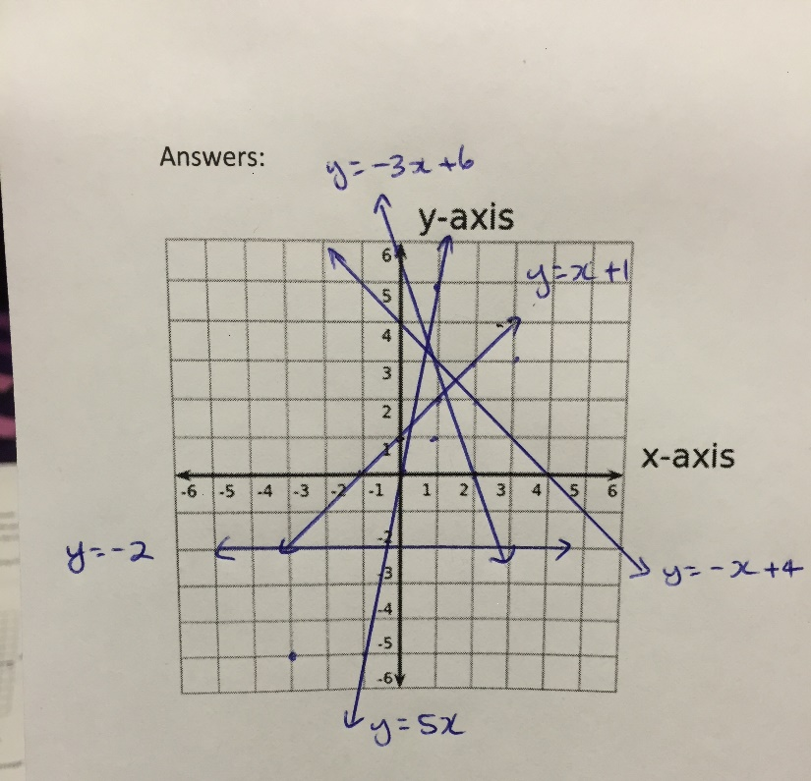

y = x + 1
x-intercept -1 coordinates (-1, 0)
y-intercept 1 coordinates (0, 1)
Gradient positive

y = 5x
x-intercept 0 coordinates (0, 0)
y-intercept 0 coordinates (0, 1)
Gradient positive

y = -3x + 6
x-intercept 2 coordinates (2, 0)
y-intercept 6 coordinates (0, 6)
Gradient negative

y = -x + 4
x-intercept 4 coordinates (4, 0)
y-intercept 4 coordinates (0, 4)
Gradient negative

y = -2
x-intercept none coordinates n/a
y-intercept -2 coordinates (0, -2)
Gradien t zero

