Smartie Percentages

- How many Smarties are there in your box?

- How many colours are there?
Write the names of the colours in the first column

- Count the number of each colour and fill in the second column

Colour | Number of Smarties | Fraction of Total Smarties | Simplified  Fraction | Decimal | Percentage
Total

- Now write the number of each colour as a fraction of the total in the third column

- Some fractions can be simplified e.g. 4/6 = 2/3.
Can you simplify any of your fractions?
Write the fraction for each colour in simplified form in the fourth column

- Express each fraction as a decimal in the fifth column

- Now calculate the percentage of each colour in the last column

- Calculate the totals of each column and enter in the last row labeled ‘Total’.

- If they made a super snack size box of Smarties that had 200% more Smarties than your box, how many Smarties would it contain?

___________________________________________________________________

- If you opened another box and found 15 Smarties in it, what percent difference is that compared to the number of Smarties in your box?

___________________________________________________________________

- Complete the first row of the table below with your total number of Smarties.
Now for the fun bit, you may eat one Smartie!
Complete the second row of the table with the number of Smarties remaining as a fraction of the original total.
Keep eating one Smartie at a time, filling in each successive row as you do.

Number of Smarties | Fraction | Simplified fraction | Decimal | Percentage
 |  | $$\frac{1}{1}$$ | 1.0 | 100%

- If you wanted to compare the amount of Smarties of each colour in your box with other groups, what would be the best way to compare answers and why?
________________________________________________________________________________________________________________________________________
____________________________________________________________________

- A factory will produce the same amount of each coloured Smartie.
What percentage of each colour should you then expect in every box?
________________________________________________________________________________________________________________________________________
____________________________________________________________________

- Suggest some reasons why you did or didn’t get the same distribution of Smartie colours in your box to the percentage you calculated in Q13.
__________________________________________________________________________________________________________________________________________
__________________________________________________________________________________________________________________________________________

- Create a fair method to evenly divide your box of Smarties between you and your two friends and explain how you chose to divide the box and why you think it is fair.
_____________________________________________________________________
_______________________________________________________________________________________________________________________________________________________________________________________________________________
__________________________________________________________________________________________________________________________________________

Additional Activities

- Collect at least 4 other group’s data about the percentages of coloured Smarties they found in their box and create an Excel Spreadsheet to display the data.

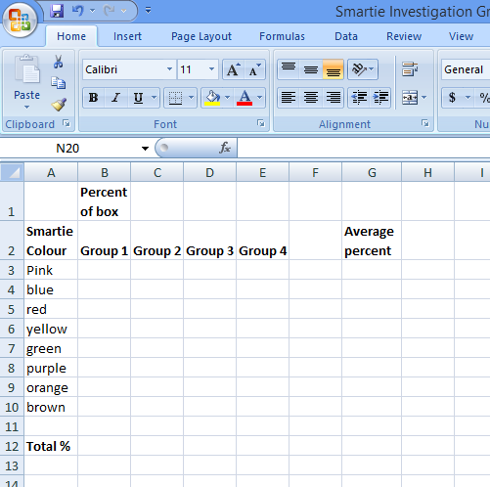

- Create a formula to calculate the total percent of each group.
What should each total be?

- Create another formula to calculate the average percent of each colour for all the groups. Explain your findings, relating them back to the expected distribution for each colour you found in Q13.

_____________________________________________________________________
_______________________________________________________________________________________________________________________________________________________________________________________________________________
__________________________________________________________________________________________________________________________________________

19. a) Create a method to predict how many Smarties might be in a 50g box.
List the number of each colour you might expect to see

_____________________________________________________________________
_______________________________________________________________________________________________________________________________________________________________________________________________________________
__________________________________________________________________________________________________________________________________________

b) Compare your predicted number to the actual amount and explain your results.
_____________________________________________________________________
_______________________________________________________________________________________________________________________________________________________________________________________________________________
__________________________________________________________________________________________________________________________________________

TEACHER NOTES:

- Check with students about food allergies before beginning the activity.

- Calculators can be allowed or not, depending on the focus of the activity.

- Smartie boxes can be rigged so weaker students can have an even number (such as 10) and more advanced students have an odd number.

- The Additional Activities suggestions can be used for extension activities or to turn the worksheet into an assignment over several lessons.

Note: Questions 1-15 take about an average lesson to complete.

