Promoting a Positive Learning Environment
A handbook to promote and maintain a positive learning environment
Christine Kusznir a1104497

Contents

Introduction ………………………………………………………………..3

Preventative Actions ………………………………………………………………..4

Supportive Actions ………………………………………………………………..7

Corrective Actions ………………………………………………………………..10

References ………………………………………………………………..13

Appendices ………………………………………………………………..15

Introduction

‘Promoting a Positive Learning Environment’ is designed as a quick reference for teaching strategies to use in the classroom to promote, support and maintain a positive learning environment. It is written as a very basic and concise pre-service teacher’s survival guide to teaching practice and classroom strategies with references to case studies and selected relevant theory.
The handbook is divided into three sections with greater focus on preventative and supportive action strategies to minimise the need for corrective actions.
Preventative actions are ranked in suggested frequency of use while supportive actions are grouped by general, student focus and lesson and learning support. The corrective action section gives some strategies on responding to common misbehavior problems.
Each action strategy has been assigned a number for easy reference and many contain a video moment and theory link with any relevant discussion or highlight. For in depth case studies and theory description please refer to the appendices.
Abbreviations | Reference | Page
P#, example P1 | Preventative Action | 4-6
S#, example S1 | Supportive Action | 7-10
C#, example C1 | Corrective Action | 10-11
CS 1 | Case Study 1 Praise and Preparation – Amy Alexander | A8, pg 22
CS 2 | Case Study 2 Manage that Class – Jenny Campbell Year 8 Science | A8, pg 23
CS 3 | Case Study 3 Too Much Talk – John Fuentes | A8, pg 24
CS 4 | Case Study 4 The need for structure – Michelle Rock | A8, pg 25
A1 | Appendix 1 Maslow’s Hierarchy of Needs | 15
A2 | Appendix 2 Kounin’s Theory - a brief description | 16
A3 | Appendix 3 Vygotsky - a brief description | 17
A4 | Appendix 4 Hierarchy of Management Intervention | 18
A5 | Appendix 5 Glasser’s Discipline Model | 19
A6 | Appendix 6 Skinner Theory of Classroom Managment | 20
A7 | Appendix 7 Fundementals of Dreikurs’ Social Discipline Model | 21
A8 | Appendix 8 Case Studies | 22
Preventative Actions
Using these actions will help prevent misbehavior because students are treated with respect and sensitivity, and are provided with an interesting curriculum and lesson activities to promote constructive behavior.
Note as the actions move from practical classroom strategies to building and maintaining personal relationships with students, the frequency they are suggested to be used increases from first contact (grey), daily (blue), regularly (orange) and always (green). Rewards are encouraged as often as possible but only as earned (pink).

Action | Strategy | When to Use | Why to Use | Video  Link | Example  And Elaboration | Linked Actions | Theoretical  Reference
P1 | Discussing classroom practices with students | The beginning of your time with students (start of year/term /day) or when entering a new classroom. | Students understand student and teacher expectations, they feel ownership of the classroom and a valued member
P2a | Routine in the classroom | Establish and follow a daily routine early on. Use consistently | Students understand what is expected of them | CS 1  1:50 | “Copy date, title, aim”  *Amy has her lesson prepared with instructions already on the board. |  | A1 Maslow’s Needs  2. Security: Need of stability through routine
P2b | Unconscious routine | ‘Train’ students into unconscious routines | Routines a teacher may use without student awareness, to prevent appearance of lots of rules
P3 | Preparation of lessons | Regularly | Time management, aids in routine, gives time for behavior management | CS 1  4:40 | Colour coding work on the board – key words, instructions, homework | P2a, P4
P4 | Well structured lessons | Regularly | Assists in classroom time management, behavior management, clear learning objectives | CS 2  2:00 | Clear lesson objective: “By the end of today you should…” |  | A2 Kounin’s Theory: maintain the flow of a lesson and have smooth transitions between activities  A1 Maslow’s Needs  2. Security: Need of stability through routine
P5 | Meaningful and enjoyable lesson activities | Regularly | Engage students for learning and behavior management |  |  |  | Lessons which are too easy, too hard, not engaging or stimulating enough can lead to student misbehavior (Wilkinson & Meiers 2007)
P6 | Clear instructions | Regularly | Assist with behavior and time management
P7 | Prepared extension work | As required for extension students | Engage and keep students on task who complete their work quickly | CS 1  5:50 | Extension activities written on the board | P3
P8 | Repetition | As required | To aid in delivering clear instructions
P9 | Catch phrases | Regularly | Part of classroom routine, to focus student attention | CS 2  4:51 | Repetition of a catch phrase: “Pens down”
P10 | Alert individual positive behaviour | As required, regularly | Reinforce positive behavior | CS 2  7:50 | “Group over here has followed my instructions, well done girls.” | P14 | A6 Skinner  Positive reinforcement and operant conditioning
P11 | Foster respectful relationships | Always | Mutual respect and consistency in the classroom |  |  |  | A1 Maslow’s Needs  *See note
P12 | Modeling appropriate behaviours | Always | Mutual respect and role model for students
P13 | Being mindful of student needs | Always | Because the teacher genuinely cares about the students which fosters respect | CS 1  13:00 | Amy explains how she got to know students through an “All about me” questionnaire | P11 | A1 Maslow’s Needs  *See note
P14 | Praise | As often as possible | Boosts student confidence and self esteem, promoting good behavior, reward, promote students to excel | CS 1  2:00 | “Thankyou! Fantastic! Excellent!”  *Amy explains “These kids respond so well to praise. At home, some of them are being told how terrible they are and they just switch off immediately. If you can calm that down and tell them how wonderful they are, that's all any kid needs.” | P11  P13 | A1 Maslow’s Needs  for students  3. Social: Need of belonging and affection  4. Esteem: Need of self esteem, personal worth, social recognition and accomplishment  May lead to  5. Self-actualization: interested in fulfilling their potential
P15 | Classroom rewards system | When earned and always when promised | Reinforce good behaviour | CS 1  2:30 | Writing students names on the board who are on task  *Pre established reward system including positive postcard home to parents and earning stars to be invited on a school trip | P11  P13 | A6 Skinner  Positive reinforcement and operant conditioning

Praise and classroom rewards must be given and allocated genuinely. They can be relative to the class or individual and used when appropriate but the teacher should always be looking for opportunities to praise and reward.

*A2 Maslow’s Needs
The teacher is mindful of all levels of needs of students.

1. Physiological Needs: Basic needs of air, sleep and food
The teacher’s foremost concern is students are healthy at school and not neglected at home because the care about the students well being.
2. Security: Teachers are always alert to student safety at school and home, their physical and mental wellbeing. In providing routines and well planned lessons, they provide a sense of stability for the student.
3. Social: By promoting a positive and safe classroom, teachers foster an environment for student’s social needs of belonging, affection and friendships to be met. They promote and encourage student involvement.
4. Esteem: After the first three needs have been satisfied, opportunities for self esteem, personal worth, social recognition and accomplishment development can be presented in the classroom though well prepared, structured, meaningful and enjoyable lessons and learning activities and feedback, praise and recognition.
5. Self-actualization: The highest level of need, only possible when all others have been satisfied and is the aim of a teacher to move every student up to this level at some point.
By being mindful of ALL student needs, a teacher will develop meaningful and respectful relationships with students.
The AITSL website describes teachers are to be involved with the physical, social and intellectual development and characteristics of students.
Supportive Actions
Teachers are regularly reading the classroom and reacting when students become off task or bored by responding in a number of ways with supportive actions. Note actions decrease in suggested frequency. They are grouped by general classroom strategies (grey), attention focus -whole class and individual (orange) and lesson and learning activity support (blue).
Action | Strategy | When to Use | Why to Use | Video  Link | Example  And Elaboration | Linked Actions | Theoretical  Reference
S1 | Showing interest | Regularly | Focus student attention back on task showing a genuine care and inclusion in the class |  |  |  | A1 Maslow’s Needs
S2a | Acknowledge misbehavior  ‘Ripple Effect’ | As required | Correcting one student leads to others modifying their behavior to avoid being corrected themselves. | CS 3  1:26 | Jenny instructs “Lose the gum”, and asks “Anyone else?” which leads to another student disposing of their gum | C3, C4 | A2 Kounin’s Theory: ‘The Ripple Effect’  Correcting one student’s behavior leads to other students correcting their behavior without being told.
S2b | Acknowledge good behavior  Variation on the  ‘Ripple Effect’ | Regularly | Reinforce and give attention to correct and on task behaviour |  |  | P14  P15 | A2 Kounin’s Theory: ‘The Ripple Effect’  Variation – by focusing on and alerting the class to individual positive behavior, students will seek to be praised also and will realize they need to change their behavior to match.  A6 Skinner  Positive reinforcement and operant conditioning
S3 | Humor | Regularly | To diffuse situations and redirect off task behaviour |  |  |  | A4 Level 2 verbal intervention in heirachy system
S4 | Classroom rules or reward system reminder | As required | Reminder or reference to classroom reward system or classroom rules to motivate or discourage behaviour |  |  |  | A4 Level 2 verbal intervention Reminder of Rules  A6 Skinner  Behaviour reinforcement and operant conditioning
S5 | Repetition | When initial cue for attention is not enough | To focus student attention |  |  |  | A4 Level 2 verbal intervention  Canter’s Broken Record – continuously repeating a redirection and avoiding verbal battle with a student
S6 | ’Wait time’ | When initial cue for attention is not enough | To focus student attention, a contrast strategy to repetition | CS 2  4:20 | Jenny remaining perfectly still and waits to regain student attention  *By repeating this action over and over again during the class, she is unconsciously training her students to respond because they know her expectations | P2b  S7
S7 | Body language | When required | A non-verbal cue to show teacher is aware of behavior yet not interrupting teaching (whole class/group/ individual) | CS 3  2:40 | *John is encouraged to find a teaching position and use movement to deliberately focus, not distract student attention. |  | A2 Kounin’s Theory: handle misbehavior while keeping the flow of the lesson
S8a | Physical proximity  (non-verbal) | When required | A non-verbal cue to show teacher is aware of behavior yet not interrupting teaching (usually group/individual) | CS 2  3:20 | When interrupted, Jenny walks across the classroom to stand close to disruptive students, gains attention and moves back to resume teaching  *Jenny creates a ‘teaching position’ and non verbally ‘teaching’ students when she is there they need to pay attention | S5  S6  S7 | A4 Level 1 non verbal intervention  A2 Kounin’s Theory: handle misbehavior while keeping the flow of the lesson
S8b | Physical Proximity  Verbal  ‘Whisper technique’ | When required | A quiet, private word in students’ ear. Positive or to alert behavior of student | CS 1  8:30 | “Is this your seat?”  *Amy uses an open ended question to alert individual student behavior in close proximity, who then immediately moves. This moment is non threatening and informal but gives an immediate, direct result. | C3 | A4 Level 2 verbal intervention, making disruptive students aware of their behavior and the effect of it but doing so privately for minor misdemeanors or to praise student without drawing attention
S9 | Distract or divert  (With a question/task) | As required | To refocus an individual student |  |  |  | A4 Level 2 verbal intervention, making disruptive students aware of their behavior and the effect of it
S10 | Publicly alert student to individual behaviour | As required | To refocus an individual student by using their name or calling on them while speaking | CS 2  2:40 | Use of names to alert individual behaviour: ”Vulcan..” | S2a | A4 Level 2 verbal intervention, a very informal warning
S11 | Remove distractions | If required | If individual student is off task due to particular object or other student | CS 4  0:35 | Directing students to specific seats: “Sit here today”  *Using a corrective action as a supportive action for student engagement | C6
S12 | Scaffolding up and down | As required | With group or individual who is off task due to task deemed too hard or easy |  |  |  | A3 Vygotsky  Zone of Proximal Development to help students learn new skills  A1 Maslow’s Needs  4. Esteem: need for accomplishment to build self esteem
S13 | Provide challenge to refocus | As required | When teacher discerns students are not sufficiently challenged. With group or individual |  |  | P3
S14 | Change the activity | As required | When lesson plan or activity is not working well | CS3  4:46 | *John has been talking for 15 minutes and students are becoming disengaged. It has been suggested he invite more student participation (change the activity)to reengage them and | P3  P4  P5 | A2 Kounin’s Theory: Teacher ‘with-it-ness’ to read the class and know when to transition to another activity

Corrective Actions
Corrective actions intervene directly with behaviour.
When possible, speak to student or group first and give choices and outline consequences.
Always follow through.
Give warnings, record incidents/behavior, proceed and invoke corrective measures as necessary. The actions outlined are not necessarily to be followed in sequence but at the teacher’s discretion.
See school policy or plan about behavior management and treat every student and incident fairly, consistently and on a case-by-case basis.

Action | Strategy | When to Use | Why to Use | Video  Link | Example  And Elaboration | Linked Actions | Theoretical  Reference
C1 | Proximity and body language | As required | Use body language to show authority
C2 | Speak to students individually | As required | Can be done privately during or after class. | CS 2  10:20 | “Speak to you two in a moment.”  Jenny corrects the misbehaving students but does not interrupt her work with another group by giving attention to negative behavior. | S2a | A5 Questioning offending students using Glasser’s Triplets to focus student attention on their behavior  A4 Level 2 verbal intervention
C3 | Reinforce classroom rules and instructions and always follow through | As required | Prevent further inappropriate behavior from other students | CS 3  1:20 | “Red star because you’ve forgotten your book again.”  *Gain students respect by following through on rules, making an example of a student so others learn | S2a
C4 | Give choice and consequence | As required | Informal, alert student to unacceptable
C5 | Give warning | As required | Informal or formal, keep record
C6 | Separate troublesome students | If required | After choice, consequence and warning, separate students to stop unacceptable behavior
C7 | Isolate troublesome student |  | Isolate student to stop unacceptable behaviour
C8 | Follow the behavior management policy as described by the school | As required | Use school corrective pathways/procedure or as previously discussed with student

The teacher must always correct and address the behavior and not the student. If student behavior requires a corrective action, a deeper classroom strategy is to seek out reasons for this behavior. Rudolf Dreikurs Goal Centered Theory for classroom management suggests a teacher must first establish a democratic teaching style, engage the whole class in discussion about acceptable behavior, rules, and expectations and use logical consequences and choice instead of punishment (P1, P11, P12, P13, A2 Maslow’s Needs). This environment will foster mutual respect and meet students’ social need to feel valued and belong and misbehaviours occur when student mistakenly believe these will help them achieve social status in the classroom. These misbehaviours include:
- Inappropriately gaining attention
- Exercising power
- Exacting revenge
- Displaying inadequacy
Some suggested strategies for these are outlined in appendix 7 (A7) and are outlined in the preventative and supportive actions in the previous sections. By understanding student behavior rather than simply responding according to step by step procedure can enhance student teacher relationships and prevent future chronic misbehavior (Lyons, Ford, Arthur-Kelly, 2011 pg7).
As Benjamin Franklin said: “An ounce of prevention is worth a pound of cure”!
Building relationships, fostering mutual respect and promoting a positive classroom is designed to reduce the amount of corrective strategies required which is why higher focus and discussion has been placed on preventative and supportive strategies in this handbook. Always remember that one strategy does not always fit all situations and every classroom, student, behavior and lesson is highly individual and depends on endless controllable and uncontrollable variables.
Be caring, kind, sharp, flexible, ‘with-it’ and handle everything with integrity and a sprinkle of humor.

References
About Education 2015, [Accessed 25 April, 2015] URL: http://psychology.about.com/od/theoriesofpersonality/ss/maslows-needs-hierarchy_6.htm

Australian Teaching for School Leadership Website, 2015 [Accessed 20 April, 2015] URL: http://www.aitsl.edu.au/australian-professional-standards-for-teachers/standards/list

C. M. Charles, Pearson, Building Classroom Discipline 2005 [Accesed April 24, 2015] URL:faculty.washington.edu/dcheney/.../Readings/CanterChapter.pdf
GoodReads 2015 [Accessed May 2, 2015] URL: http://www.goodreads.com/quotes/tag/prevention
Krause, K. Bochner, S. Duchesne, S. Educational Psychology for learning and teaching, 2003 chapter 2 Cognitive Development

Lecture Notes from Student Teacher Interaction semester 1, weeks 1-3 and, 6 Graduate Diploma of Education, 2015
Levin, James and James F. Nolan. Principles of Classroom Management: A Professional Decision-Making Model. 4th ed. MA: Pearson Education, Inc., 2004

Lyons, Ford, Arthur-Kelly Classroom Management, Cengage 2011, Ch 1,7)
McLeod, S. A. (2007). Lev Vygotsky. [via Simply Psychology, accessed April 25, 2015] URL: http://www.simplypsychology.org/vygotsky.html

The Glasser Model 2015, [Accessed 25 April, 2015] URL: https://sites.google.com/site/thebehavioranalysismodel/

Wikibooks 2015 Foundations of Constructivism/Contributors/Jean Piaget and Lev Vygotsky [Accessed May 2, 2015] URL: http://en.wikibooks.org/wiki/Foundations_of_Constructivism/Contributors/Jean_Piaget_and_Lev_Vygotsky#Key_Concepts_Contributed_to_Constructivist_Theory:_Vygotsky

Wikibooks 2015 Classroom Management Theorists and Theories/Jacob Kounin [Accessed April 23, 2015] URL: http://en.wikibooks.org/wiki/Classroom_Management_Theorists_and_Theories/Jacob_Kounin (Kounin, J. S. Discipline and Group Management in Classrooms. Holt, Reinhardt and Winston, 1970)

Wikibooks 2015 Classroom Management Theorists and Theories/Burrhus Frederic Skinner [Accessed May 2, 2015] URL: http://en.wikibooks.org/wiki/Classroom_Management_Theorists_and_Theories/Burrhus_Frederic_Skinner
Wikibooks 2015 Classroom Management Theorists and Theories/Ruldpolf Dreikurs [Accessed May 4, 2015] URL: http://en.wikibooks.org/wiki/Classroom_Management_Theorists_and_Theories/Rudolf_Dreikurs
Wolfgang, C. H. (2011). Solving discipline and classroom management problems. (7 ed.). Wiley, John & Son, Inc.

Wilkinson, J. & Meiers, M. (2007) Managing student behavior in the classroom NSWIT Readers Digest, 2007 (2) Retrieved April 27, 2015 from http:www.nswteachers.nsw.edu.au

Case Studies:
SchoolsWorld 2012 Teaching with Bailey ‘Praise and Preparation’[Viewed April 22, 2015]
URL: http://www.schoolsworld.tv/node/273

SchoolsWorld 2012 Teaching with Bailey ‘Manage that class – year 8 Science’ [Viewed April 22, 2015]
URL: http://www.schoolsworld.tv/node/1752

SchoolsWorld 2012 Teaching with Bailey ‘Too Much Talk’ [Viewed April 22, 2015]
URL: http://www.schoolsworld.tv/node/271

SchoolsWorld 2012 Teaching with Bailey ‘The need for structure’ [Viewed April 22, 2015]
URL: http://www.schoolsworld.tv/node/272

Appendix 1
Maslow’s Hierarchy of Needs

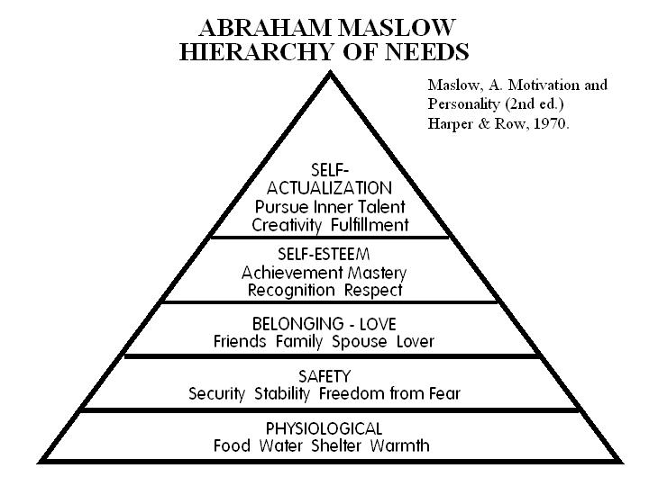

- Physiological Needs
Basic needs that are vital to survival, such as the need for water, air, food, and sleep. Maslow believed that these needs are the most basic and instinctive needs in the hierarchy because all needs become secondary until these physiological needs are met.
- Security Needs. Security needs are important for survival, but they are not as demanding as the physiological needs. Examples of security needs include a desire for steady employment, health care, safe neighborhoods, and shelter from the environment.
- Social Needs
These include needs for belonging, love, and affection. Maslow described these needs as less basic than physiological and security needs. Relationships such as friendships, romantic attachments, and families help fulfill this need for companionship and acceptance, as does involvement in social, community, or religious groups.
- Esteem Needs
After the first three needs have been satisfied, esteem needs becomes increasingly important. These include the need for things that reflect on self-esteem, personal worth, social recognition, and accomplishment.
- Self-actualizing Needs
This is the highest level of Maslow’s hierarchy of needs. Self-actualizing people are self-aware, concerned with personal growth, less concerned with the opinions of others, and interested fulfilling their potential.

Appendix 2
Kounin’s Theory - a brief description
Teachers maintain the flow of an activity and flow of a lesson by having smooth transitions between activities.
‘With-it-ness’: Teacher is aware of their classroom and can seamlessly handle minor misbehaviours while keeping the flow of the lesson
The “Ripple Effect”: The correction of one student’s behavior leads to other students stopping their misbehavior and engaging in appropriate behavior to avoid being corrected.

Appendix 3
Vygotsky (1978) - a brief description

The type of learning that Vygotsky viewed was one where the learners should discover their own truths about the world. He believed that instructors and learners are equally involved in the learning process. Vygotsky also believed that there are significant implications for peer collaborations. This also stressed the ideas of thought and speech being used to increase the learner’s ability to communicate with peers or collaborators.

Vygotsky sees the Zone of Proximal Development (ZPD) as the area where the most sensitive instruction or guidance should be given which allows the student to develop skills they will then use on their own.

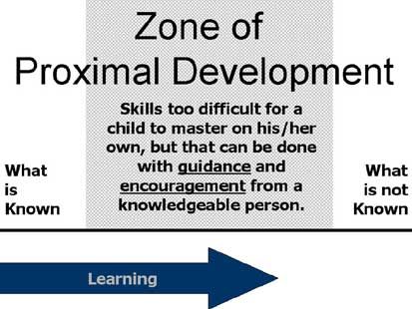

Appendix 4

Table from Levin & Nolan (2003:43) demonstrating a hierarchical system for behaviour management. The strategies begin with minimal confrontation and disruption to the lesson in Level 1 and move toward more confrontation and disruption if the previous strategies are unsuccessful.

Hierarchy of Management Intervention
(Levin & Nolan 2003)

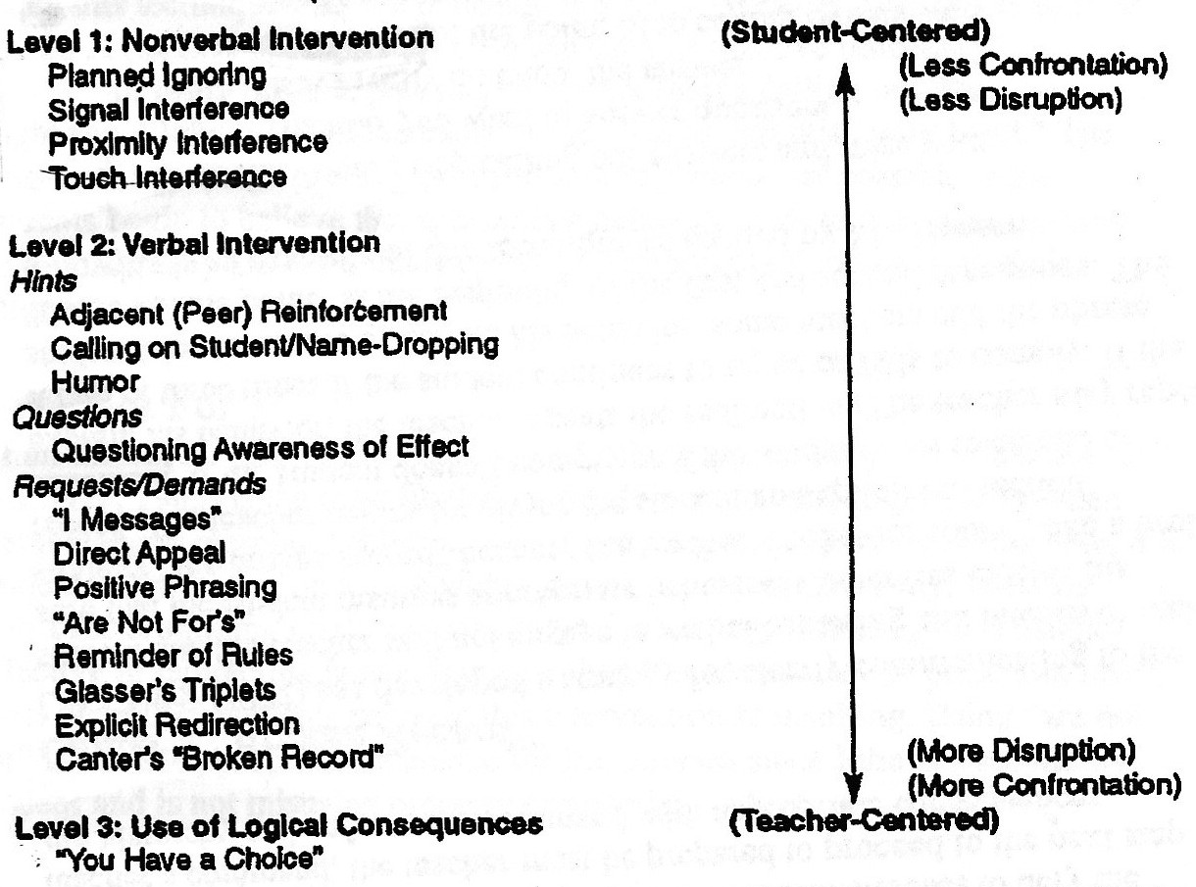

Level 1: Nonverbal Interventions
Planned Ignoring – completely and intentionally ignoring a behavior.
Signal Interference – any type of nonverbal act that sends a message to a student without disturbing other students.
Proximity Interference – any movement toward a disruptive student.
Touch Interference – not an appropriate strategy.

Level 2: Verbal Interventions
Hints
Peer Reinforcement – publicly complimenting a student who is behaving appropriately.
Name Dropping – redirecting a student to appropriate behavior by calling on a student or inserting his/her name.
Humor – humor directed at a teacher or situation to alleviate classroom tension and redirect off-task behavior.
Questions
Questioning Awareness of Effect – making disruptive students aware of their behaviors and effects of these behaviors.
Requests/Demands
I Message – communicating a disruptive behavior, effects of that behavior, and teacher’s feelings to a student.
Direct Appeal – politely asking a student to stop a misbehavior.
Positive Phrasing – stating the outcomes of a desired positive behavior instead of a negative one.
“Are Not For’s” – restricted for when students misuse property and/or materials.
Reminder of Rules – reminding students of rules that they agreed to follow.
Glasser’s Triplets – asking a student (1) What are you be doing? (2) Is it against the rules? and (3) What should you be doing?
Explicit Redirection – an assertive order from a teacher to immediately stop a misbehavior and return to acceptable behavior.
Canter’s Broken Record – continuously repeating a redirection and avoiding verbal battle with a student.

Appendix 5
Glasser’s Discipline Model

Glasser’s Discipline Model and Methods
To focus student attention on and acknowledge their behavior as responsible or irresponsible.
This will help the student make logical and productive decisions in the classroom and involves four steps (Wolfgang 2011).

1. Looking

2. Questions

3. Commanding/Reinforcing

4. Acting and Isolation

Glasser’s Triplets:
A method of questioning that a teacher can use to direct students to focus on their behaviour using three questions such as:

What are you doing?
Is it against the rules?
What should you be doing?

Appendix 6
Overview of Skinner's Theories of Classroom Management
Skinner believed that the goal of psychology should be practical (Lieberman, 2000). As it relates to education, Skinner believed the goal of psychology should be to find ways to make education enjoyable and effective for all students. His learning theory relied on the assumption that the best way to modify behavior was to modify the environment. Skinner was a proponent for many instructional strategies that modern day “progressive” educational reformers advocate for: scaffold instruction, small units, repetition and review of instructions, and immediate feedback. Skinner did not approve of the use of punishments in school, or as a behavioral modification technique in general, and based these opinions on his own empirical research that found punishments to be ineffective (Lieberman, 2000). Skinner himself advocated for the frequent use of reinforcement (i.e. rewards) to modify and influence student behavior.
Skinner’s primary contribution to behavioral management philosophy has been from his research on operant conditioning and reinforcement schedules. An operant is a behavior that acts on the surrounding environment to produce a consequence. As a result of the consequence, the operant’s likelihood of reoccurring is affected. The operant is said to be reinforced if the consequence increases the likelihood of the behavior's occurrence.
Secondary Implementation of Skinner's Theories
In order to apply Skinner’s theories in your own secondary classroom, you could do the following:
- Create (with student input, if necessary) a system of positive incentives for individual, group, and class behavior. Reward positive behavior before reprimanding negative behavior (for example, instead of punishing one student for not turning in homework, give all other students who did turn in homework consistent rewards until that will induce that one student to follow suit with the rest of class).
- Ensure that positive reinforcement is immediate so that it can be associated with the positive behavior. This is crucial especially when secondary teachers see students for such a small portion of each day.
- Recognize the unique instructional needs of individual students and individual periods and modify instructional material and methods appropriately.
- Provide feedback as students work, not just after they are finished with a particular task.
- Ensure that students have mastered prerequisite skills before moving on, even if this puts different periods of the same class on different tracks.
- Reinforce positive behaviors students exhibit, either with problem students or with whole class to refocus problem students

Appendix 7 FUNDEMENTALS OF DREIKURS' SOCIAL DISCIPLINE MODEL

Dreikurs' Social Discipline model is based on the four basic premises of Adler's social theory. These premises are:
- Humans are social beings and their basic motivation is to belong
- All behavior has a purpose
- Humans are decision-making organisms
- Humans only perceive reality and this perception may be mistaken or biased
Essentially, every action of the child is grounded in the idea that he is seeking his place in the group. A well-adjusted child will conform to the requirements of the group by making valuable contributions. A child who misbehaves, on the other hand, will defy the needs of the group situation in order to maintain social status. Whichever of the aforementioned goals he chooses to employ, the child believes that this is the only way he can function within the group dynamic successfully. Dreikurs states that "his goal may occasionally vary with the circumstances: he may act to attract attention at one moment, and assert his power or seek revenge at another" (Dreikurs, 1968, p.27). Regardless if the child is well-adjusted or is misbehaving, his main purpose will be social acceptance.
The following are techniques that can be used to address the four goals of misbehavior:
A. Attention Getting
  - Minimize the Attention - Ignore the behavior, stand close by, write a note
  - Legitimize the Behavior - Create a lesson out of the behavior, have the class join in the behaviors
  - Do the Unexpected - Turn out the lights, play a musical instrument, talk to the wall
  - Distract the Student - Ask a question or a favor, change the activity
  - Recognize Appropriate Behavior - Thanks students, give them a written note of congratulations
  - Move the Student - Ask the student to sit at another seat, send the student to a "thinking chair"
B. Seeking Power and Control
  - Make a Graceful Exit - Acknowledge student's power, remove audience, table matter for later discussion,
  - Use a Time-Out
  - Apply the Consequence
C. Seeking Revenge
  - Same as for "Contest for Power"
D. Displaying Inadequacy
  - Modify Instructional Methods
  - Use Concrete Learning Materials and Computer-Enhanced Instruction
  - Teach One Step at a Time (or break instruction into smaller parts)
  - Provide Tutoring
  - Teach Positive Self-Talk and Speech
  - Teach that Mistakes are Okay
  - Build Student's Confidence
  - Focus on Past Successes
  - Make Learning Tangible
  - Recognize Achievement

Appendix 8 Case Studies
The following case studies refer to videos clips from Teachers TV and show some examples of strategies used in a context (approximate times shown as (minute:second) with links to the main and indirect strategies outlined in this handbook and some elaborations (*in italics) and comments below.
Case Study 1 Praise and Preparation – Amy Alexander
Time | Specific Example | Main Strategy | Indirect Strategy
1:20 | Classroom routine, repetition of instructions | P2, P8
1:50 | “Copy date, title, aim”  *Amy has her lesson prepared with instructions already on the board. | P2 | P3
2:00 | Using praise: “Thankyou! Fantastic! Excellent!”  *Amy explains “These kids respond so well to praise. At home, some of them are being told how terrible they are and they just switch off immediately. If you can calm that down and tell them how wonderful they are, that's all any kid needs.” | P14
2:30 | Writing students names on the board who are on task  *Pre established reward system including positive postcard home to parents and earning stars to be invited on a school trip | P10/P15  S2 | P11  P2
4:40 | Colour coding work on the board – key words, instructions, homework | P3 | P2, P6
5:50 | Extension activities written on the board | P7 | P3, P4
8:30 | Whisper technique: “Is this your seat?”  *Amy uses an open ended question to alert individual student behavior in close proximity, who then immediately moves. This moment is non threatening and informal but gives an immediate, direct result. | S8b | C2
13:00 | Amy explains how she got to know students through an “All about me” questionnaire | P13

Amy’s main strategy to promote her positive learning environment and manage student behavior is through preventative strategies such as highly organized, structured routine and lesson planning, lots of engaging activities and student participation. She uses high levels of praise to promote positive behavior as she recognizes the need of a positive environment, affection and self esteem for the students through getting to know them from questionnaires and fostering respectful relationships with them.
Amy manages behavior by keeping the students busy at all times and differentiating through extension activities.
Note that majority of strategies Amy uses are preventative with only an occasional supportive/corrective. This suggests she has spent a lot of time and effort promoting a positive learning environment and the result is obvious.
Case Study 2 Manage that Class – Jenny Campbell Year 8 Science (Friday afternoon)
Time | Specific Example | Main Strategy | Indirect Strategy
2:00 | Clear lesson objective: “By the end of today you should…” | P4 | P3
2:40 | Use of names to alert individual behaviour: ”Vulcan..” | S10
3:20 | Use of body language, proximity and wait time  *When interrupted, Jenny walks across the classroom to stand close to disruptive students, gains attention and moves back to resume teaching and so creating a ‘teaching position’ and non verbally ‘teaching’ students when she is there they need to pay attention. | S7  S6  S8 | P2b
4:20 | Wait time – Jenny remaining perfectly still and waits to regain student attention  *By repeating this action over and over again during the class, she is unconsciously training her students to respond faster and faster because they know her expectations | S6  S7
4:30 | Countdown to change of activity: “10 seconds!”  *Jenny indicates how long students have to work on a task and counts them down. A useful strategy to warn students to be ready to listen, a form of repetition and catch phrase | P8  P9 | P2b
4:51 | Repetition of a catch phrase: “Pens down” | P8  P9
5:40 | Proximity: Jenny stands by off task students while continuing teaching and they refocus | S8
7:50 | Alert positive individual behavior and praise: “Group over here has followed my instructions, well done girls.” | P10  P14
10:20 | Speak to students individually about misbehavior: “Speak to you two in a moment.”  Jenny corrects the misbehaving students but does not interrupt her work with another group by giving attention to negative behavior. | C2

Jenny employs many supportive actions as her students easily stray off task. She has a difficult time of class and so has a highly structured and prepared lesson and gives clear instructions to promote her learning environment. Jenny is quick to manage off task behavior in a difficult setting.

Case Study 3 Too Much Talk – John Fuentes
Time | Specific Example | Main Strategy | Indirect Strategy
1:20 | Reinforcing classroom rules and consequences: “Red star because you’ve forgotten your book again.”  *Gain students respect by following through on rules, making an example of a student so others learn | C3
2:40 | *John is encouraged to find a teaching position and use movement to deliberately focus, not distract student attention. | S7
4:46 | *John has been talking for 15 minutes and students are becoming disengaged. It has been suggested he invite more student participation (change the activity)to reengage them and | S14

John seeks feedback about his teaching and gains confidence after seeing himself in some really great teaching moments.
A suggested area to improve on is to monitor the amount of time he spends talking as he is losing student engagement.
After being offered some advice and developing some personal specific strategies, John returns to his classroom with some differences.
7:14 | Monitoring pace of lesson: Using a timer to manage teaching time  *The students are more attentive knowing they only a specific time for each section of the lesson. Strategy is a well planned lesson and following the plan | P4
9:20 | Invite student participation for less teacher talk (change activity slightly): “Explain in your own words.” | S14 | P4

Case Study 4 The need for structure – Michelle Rock
Time | Specific Example | Main Strategy | Indirect Strategy
0:35 | Directing students to specific seats: “Sit here today”  *Using a corrective action as a supportive action for student engagement and removing distractions | S11 | C6
1:26 | Follow through with class rule: “Lose the gum”, “Anyone else?” | C3 | C3/C4  S11
4:40 | Separating students so they stay on task  *Michelle gives no choice or warning first, this could be from past experience. | C6
6:50  8:00  9:30 | *Michelle is losing student attention from too long spent on one activity and unclear instructions causing unsettling. She is encouraged to prepare and have a firmer structure to her lessons to keep students focused. | P3  P4  P6

Michelle is really being encouraged to use more preventative actions to behavior manage.
The next time we see her teach she has applied these strategies with much improvement in her class.
12:30 | *Classroom activities in sequence on the board showing lesson preparation, structure, clear instruction to have students working on task. | P3  P4  P6

Excellent examples and reminders as to why feedback is so important: to identify great moments of teaching and personal areas to work on.

