Stem Cells
The classical definition of a stem cell requires that it possess two properties:
- Self-renewal - the ability to go through numerous cycles of cell division while maintaining the undifferentiated state.
- Potency - the capacity to differentiate into specialized cell types. In the strictest sense, this requires stem cells to be either totipotent or pluripotent - to be able to give rise to any mature cell type.
Potency specifies the differentiation potential (the potential to differentiate into different cell types) of the stem cell.
- Totipotent stem cells are produced from the fusion of an egg and sperm cell. Cells produced by the first few divisions of the fertilized egg are also totipotent. These cells can differentiate into embryonic and extraembryonic cell types.
- Pluripotent stem cells are the descendants of totipotent cells and can differentiate into skin, bone or connective cells.
- Unipotent cells can produce only one cell type, but have the property of self-renewal which distinguishes them from non-stem cells (e.g. muscle stem cells).
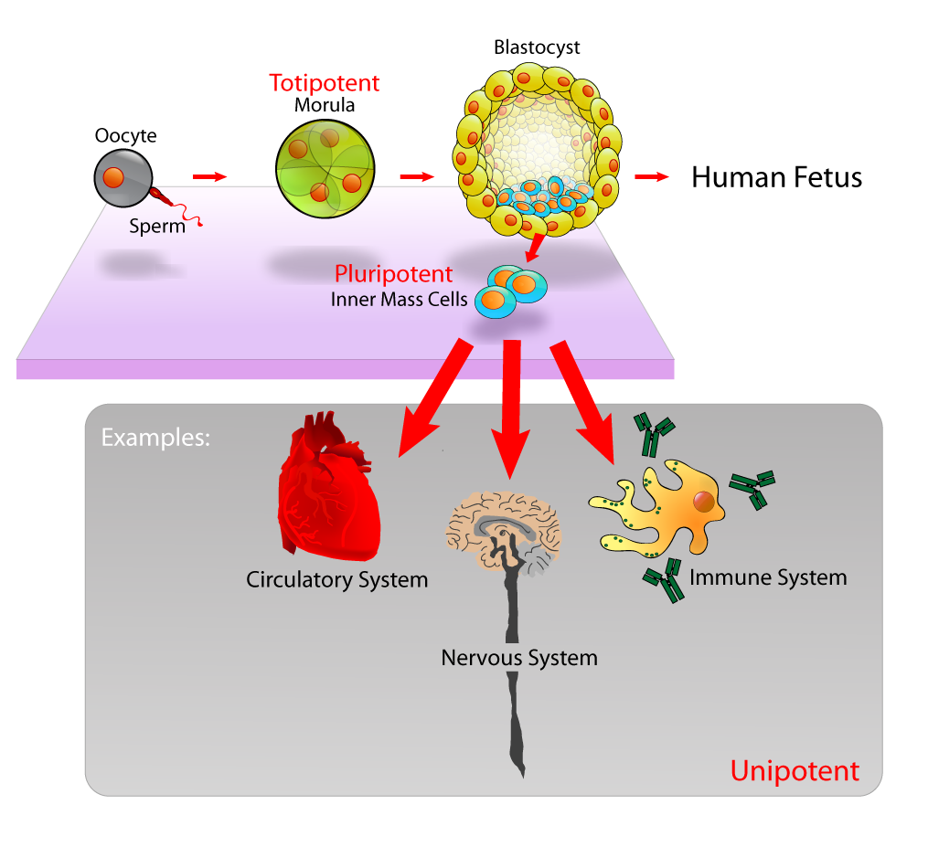

Three main types of stem cells
- Embryonic stem cells (ES)
2. Adult stem cells
3. Induced Pluripotent Stem Cells (iPSC)
Embryonic Stem Cells
- Embryonic stem cells are created by means of in vitro fertilization. They are harvested after 5-6 days from a cell know as a blastocyst. They do not come from aborted fetuses. They have the potential to change into any type of cell found in body.
- Embryonic stem cell lines (ES cell lines) are cultures of cells derived from the tissue of the inner cell mass (ICM) of a blastocyst or earlier morula stage embryos.
- A blastocyst is an early stage embryo—approximately four to five days old in humans and consisting of 50–150 cells.
- The embryos from which human embryonic stem cells are derived are typically five or six days old and are a hollow microscopic ball of cells called the blastocyst.
- ES cells require very different environments in order to maintain an undifferentiated state. Mouse ES cells are grown on a layer of gelatin and require the presence of Leukemia Inhibitory Factor (LIF).
- Human ES cells are grown on a feeder layer of mouse embryonic fibroblasts (MEFs) and require the presence of basic Fibroblast Growth Factor (bFGF or FGF-2).
- Without optimal culture conditions or genetic manipulation, embryonic stem cells will rapidly differentiate.
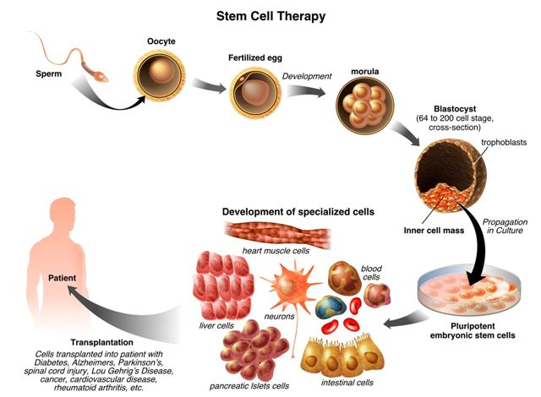
2 Sources of Embryonic Stem Cells
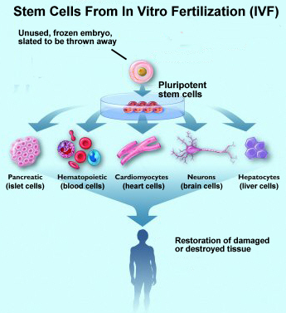
- Excess fertilized eggs from IVF (in-vitro fertilization) clinics
Tens of thousands of frozen embryos are routinely destroyed when couples finish their In Vitro Fertilization treatment.
These surplus embryos can be used to produce stem cells.
Regenerative medical research aims to develop these cells into new, healthy tissue to heal severe illnesses.

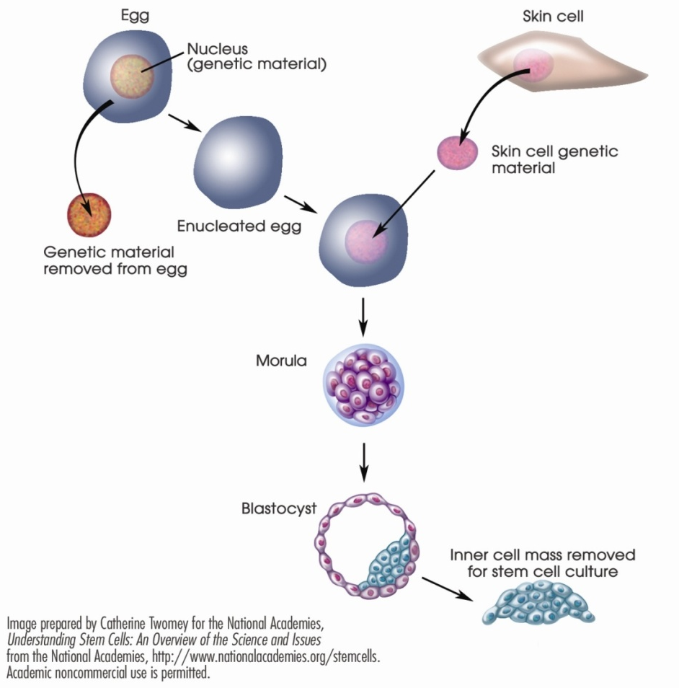
- Somatic Cell Nuclear Transfer
The nucleus of a donated egg is removed and replaced with the nucleus of a mature, "somatic cell" (a skin cell, for example).
No sperm is involved in this process, and no embryo is created to be implanted in a woman’s womb.
The resulting stem cells can potentially develop into specialized cells that are useful for treating severe illnesses.

Adult Stem Cells
- The term adult stem cell refers to any cell which is found in a developed organism that has two properties: the ability to divide and create another cell like itself and also divide and create a cell more differentiated than itself.
- The term adult stem cell refers to any cell which is found in a developed organism that has two properties: the ability to divide and create another cell like itself and also divide and create a cell more differentiated than itself.
- Pluripotent adult stem cells are rare and generally small in number but can be found in a number of tissues including umbilical cord blood.
- Adult tissues, such as bone marrow, muscle, and brain, contain adult stem cells that can generate replacements for cells that are lost through normal wear and tear, injury, or disease.
- Can be found in bone marrow. Harvested at any time in a adult person’s life. Potential to become only a limited number of specialized cells.
- The primary roles of adult stem cell in a living organism are to maintain and repair the tissue in which they are found.
- Some scientists now use the term “somatic stem cell” instead of adult stem cell.
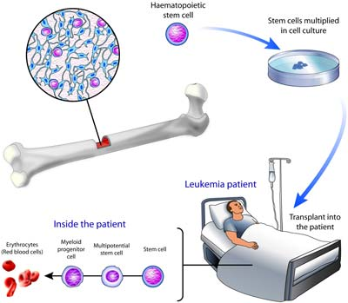

Induced Pluripotent Stem Cells (iPSC)
In the last couple of years a potential alternative to either ESC or ASC has been developed. These cells are called iPSC.
- They are generated from differentiated cells (commonly fibroblasts) which are de-differentiated or reprogrammed by modifying 4 genes using viral vectors.
- The resultant cells seem to have all the characteristics of SC.
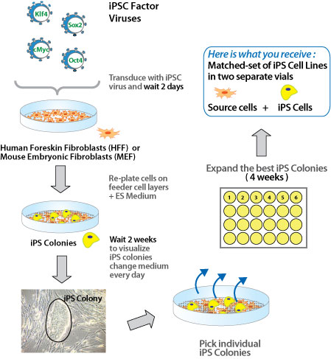
The Promise of Stem Cell use in medicine
Medical researchers believe that stem cell therapy has the potential to dramatically change the treatment of human disease. A number of adult stem cell therapies already exist, particularly bone marrow transplants that are used to treat leukemia.
In the future, medical researchers anticipate being able to use technologies derived from stem cell research to treat a wider variety of diseases including cancer, Parkinson's disease, spinal cord injuries, Amyotrophic lateral sclerosis, multiple sclerosis, and muscle damage amongst a number of other impairments and conditions.
However, there still exists a great deal of social and scientific uncertainty surrounding stem cell research, which could possibly be overcome through public debate and future research, and further education of the public.

Concerns over the use of stem cells
There still exists a great deal of social and scientific uncertainty surrounding stem cell research, which could possibly be overcome through public debate and future research, and further education of the public.
One concern of treatment is the risk that transplanted stem cells could form tumours and become cancerous if cell division continues uncontrollably.
A comparison of deriving different types of stem cells

SUMMARY
Stem cells
- Stem cells differ from other kinds of cells in the body. All stem cells have two important characteristics that distinguish them from other types of cells.
- Firstly, they are unspecialized (undifferentiated) cells that renew themselves for long periods of time through cell division of at least one daughter cell.
- Secondly, under certain physiological or experimental conditions, they can be induced to differentiate.
- This means that they can divide into cells with special functions, such as the beating cells of the heart muscle or the insulin-producing cells of the pancreas.

Sources of stem cells (embryonic, adult, iPS cells)
- Human Embryonic Stem cells are obtained from aborted foetuses or fertilized eggs.
- This has come under ethical scrutiny since use of these procedures requires serious moral consideration by society.
- A possible way to circumvent this issue would be to use stem cells isolated from adult tissues.
- Adult stem cells are obtained from certain tissues in adult organisms but are multipotent and can become a limited range of cell types.
- Recently differentiated cells have been genetically engineered to return to stem cell status.
- Called induced pluripotent cells or iPS cells, they overcome the controversial destruction of embryos to source embryonic stem cells.

Stem cell therapies
One potential application is the generation of different types of neurons for the treatment of Alzheimer’s disease, spinal cord injuries, or Parkinson’s disease.The production of heart muscle cells for heart attack survivors may also be possible.
Stem cells could also be useful in the production of complete organs including livers, kidneys, eyes, hearts, or even parts of the brain.
Intended student learning
- Explain the origin of stem cells and how they can differentiate into all the different types of cells in the body.
- Understand the meaning of differentiation.
- State the origins of stem cells.
- Understand the basis for the controversy around using some types of stem cells.
- Explain the potential applications of stem cell therapy.

